Department Of Computer Science

Gujarat University

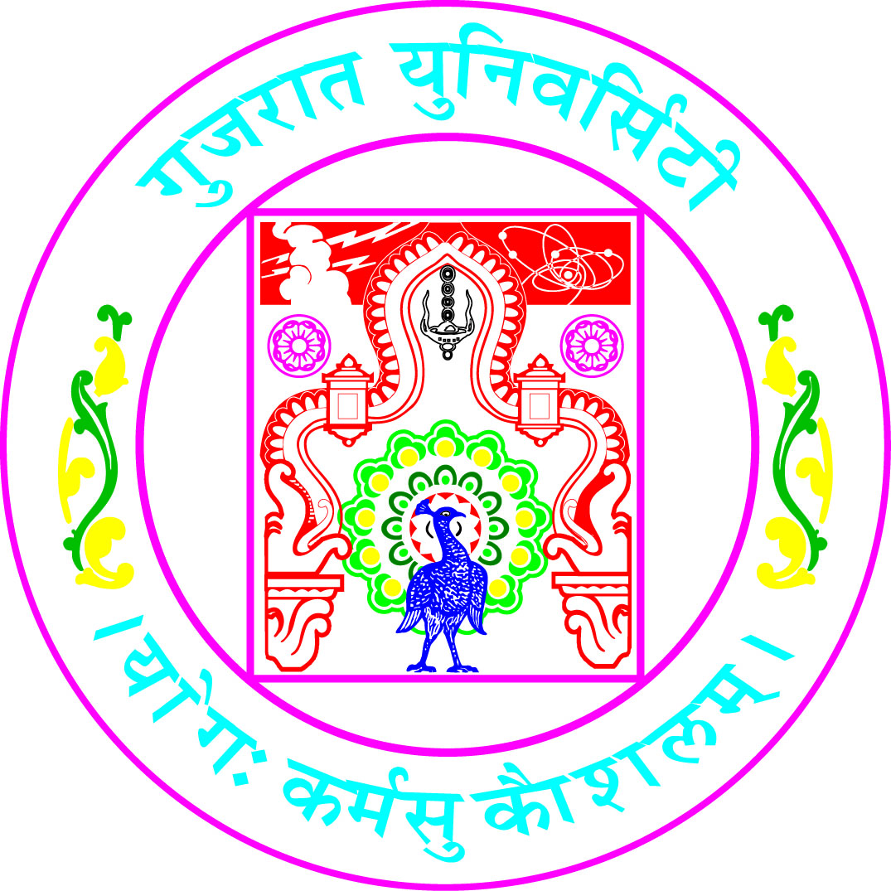

CERTIFICATE

This is to certify that project work embodied in this report entitled “Sign Language Recognition” was carried out by Mr./Ms. Singh Suraj Arvind (40016) at Department of Computer Science for partial fulfillment of M.Sc (Artificial Intelligence & Machine Learning) degree of Gujarat University. This project work has been carried out under my/our supervision and is to my/our satisfaction.

Course Coordinator Supervisor(s)
Dr. Jyoti Pareek Dr. Jyoti Pareek

Head of the Department
Dr. Jyoti Pareek

